Task-03 Report

Introduction:
This task focuses on performing Exploratory Data Analysis (EDA) to understand the structure and patterns within the dataset. Various visualization techniques such as histograms, count plots, box plots, and a correlation heatmap are used to analyze numerical and categorical features. The goal is to extract meaningful insights, detect outliers, study feature relationships, and identify important features for prediction. This analysis helps me better understand the data before applying any machine learning models.
The Work:
The dataset was first loaded using Pandas, and an initial inspection was performed using functions like head(), info(), and describe() to understand its structure, data types, and missing values. The features were then separated into numerical and categorical columns for appropriate analysis. Histograms were plotted for all numerical features to study their distributions and trends. Count plots were created for important categorical features to analyze category frequencies. Box plots were used to detect outliers and extreme values in numerical columns. A correlation matrix was computed and visualized using a heatmap to understand relationships between numerical features. Label encoding was applied to convert the categorical type of column into a numeric form. Correlations between encoded and numerical features were analyzed. Finally, important features were identified, and insights were summarized for reporting and future prediction tasks.

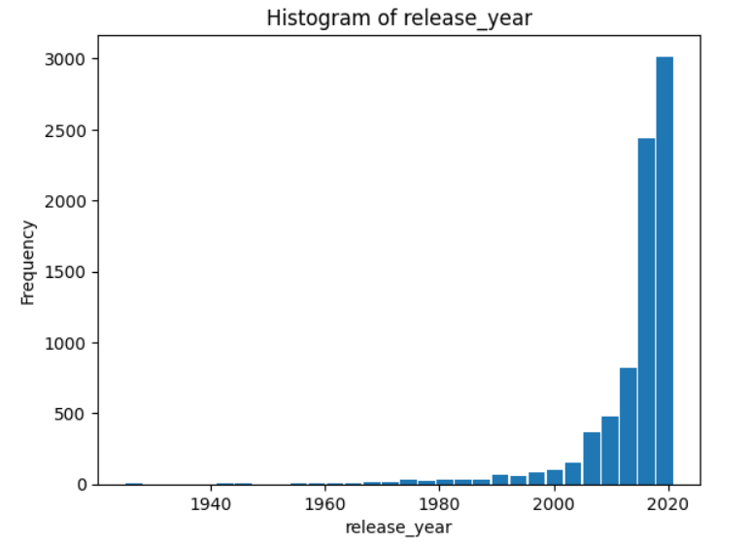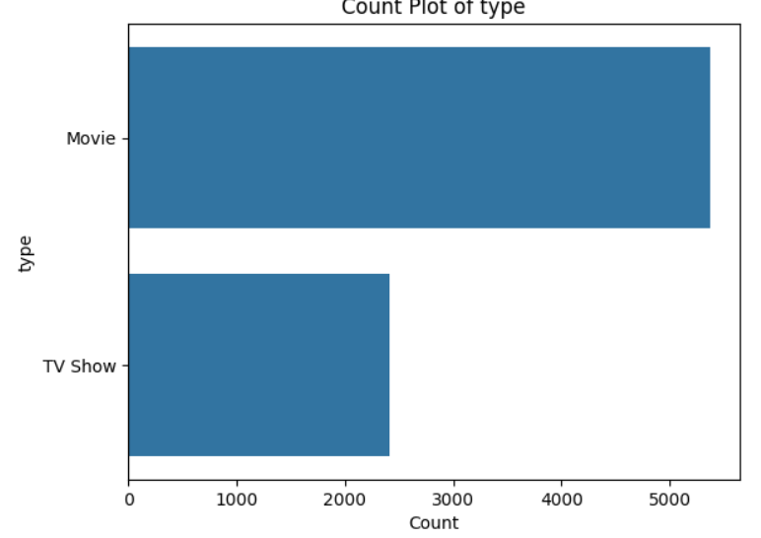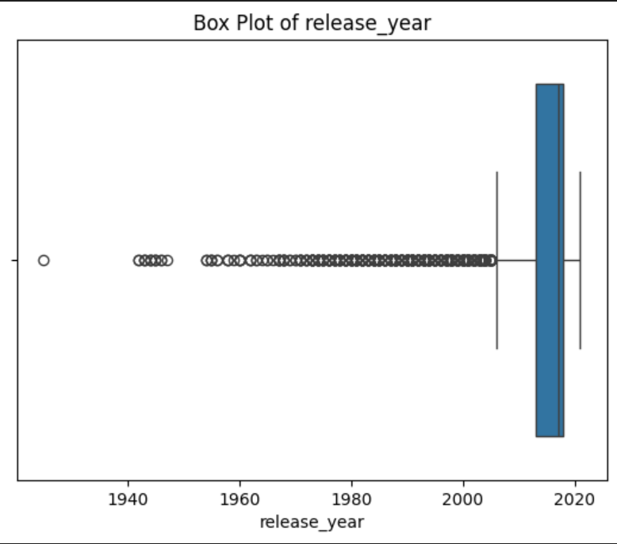
Fig-1 Histogram chart between year and frequency fig-2 count plot between movies vs tv shows fig-3 boxplot for release year

